Q03
Step01: Loading whois_pocs
Step02: Setting domain
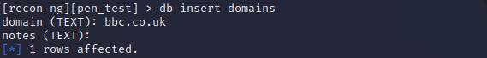
Step03: Getting output
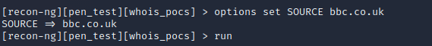
Answer:
Luz Castillo
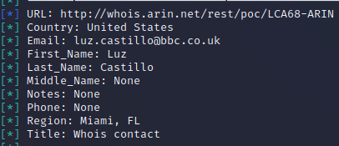

Q04
Step01: Getting IP address
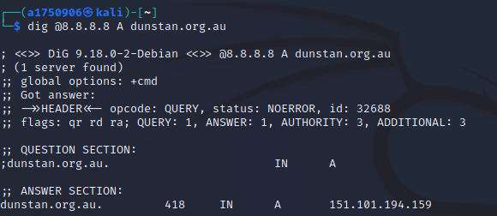
Step02: Finding other domain names that use the same IP on domaintools.com
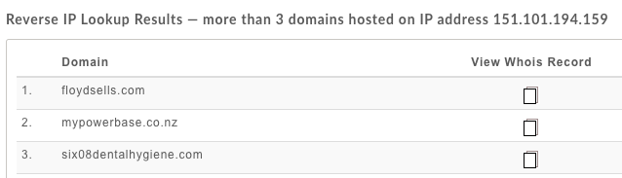
Step03: Getting whois information both from terminal and domaintools.com
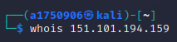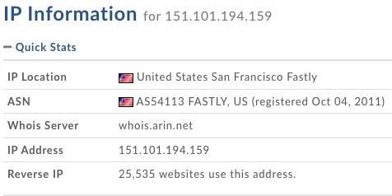
Answer:
Question | Answer
dunstan.org.au resolves to: | 151.101.194.159
Other domain names that resolve to the same address | floydsells.com  mypowerbase.co.nz  six08dentalhygiene.com
Owner of the IP address | Fastly
The IP address range which the IP address belongs | 151.101.0.0 – 151.101.255.255
The Autonomous System Number (ASN) that contain the IP address | AS54113
Other netblocks registered under the same ASN | 23.154.64.0 - 23.154.64.255  23.185.0.0 – 23.185.0.255  23.235.32.0 – 23.235.40.255  23.235.42.0 – 23.235.47.255  43.249.72.0 - 43.249.72.255  43.249.74.0 - 43.249.74.255  103.245.222.0 – 103.245.224.255  104.156.80.0 – 104.156.87.255  …

Q05
Step01: Using org:“Pfizer” to roughly scan the websites in Shodan
Step02: IIS org: “Pfizer”
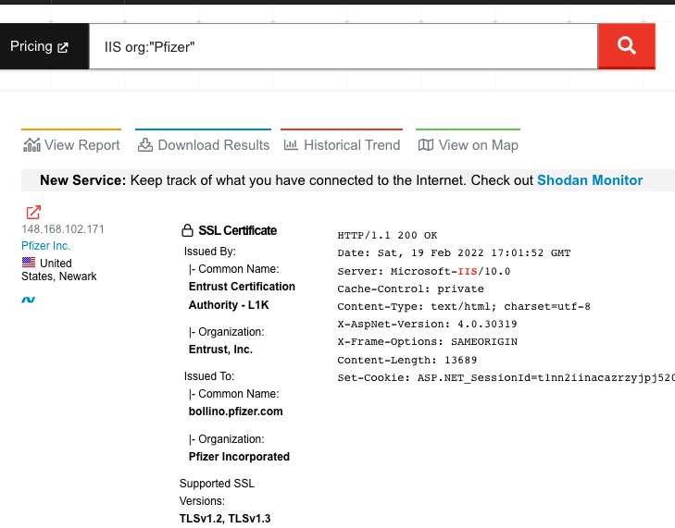
Step03: Looking for CVE-2014-4078 in nvd.nist.gov
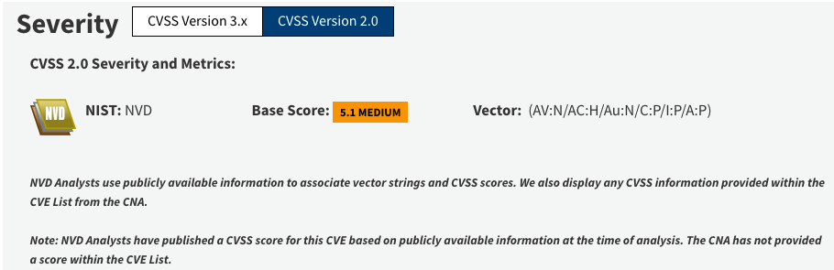
Answer:
Question | Answer
What firewall products are mainly used? | OpenSSH
What are some version(s) of IIS server is seen? | Microsoft IIS httpd 8.0  Microsoft IIS httpd 10.0
According to Shodan, what are some of the vulnerabilities in one of the versions of the IIS servers? | Microsoft IIS httpd 8.0  The IP Security feature in Microsoft Internet Information Services (IIS) 8.0 and 8.5 does not properly process wildcard allow and deny rules for domains within the "IP Address and Domain Restrictions" list, which makes it easier for remote attackers to bypass an intended rule set via an HTTP request, aka "IIS Security Feature Bypass Vulnerability."
Choose the most recent vulnerability from above, and find the CVSS2.0 string for it by looking it up on nvd.nist.gov. | AV:N/AC:H/Au:N/C:P/I:P/A:P

Q06
Step01: Using dictionary to query dns
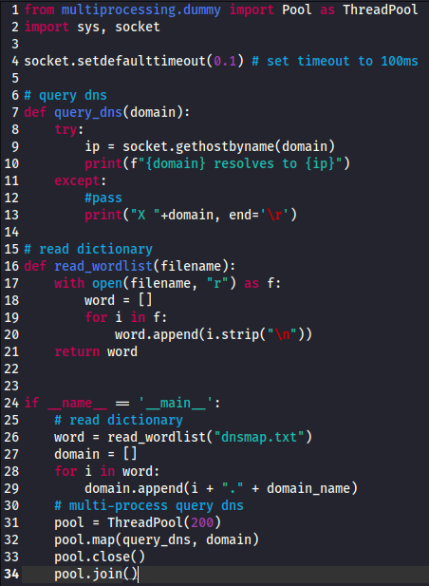
Answer:
Some results
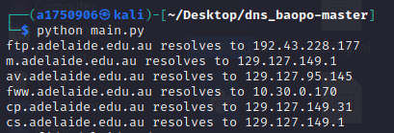

Q07
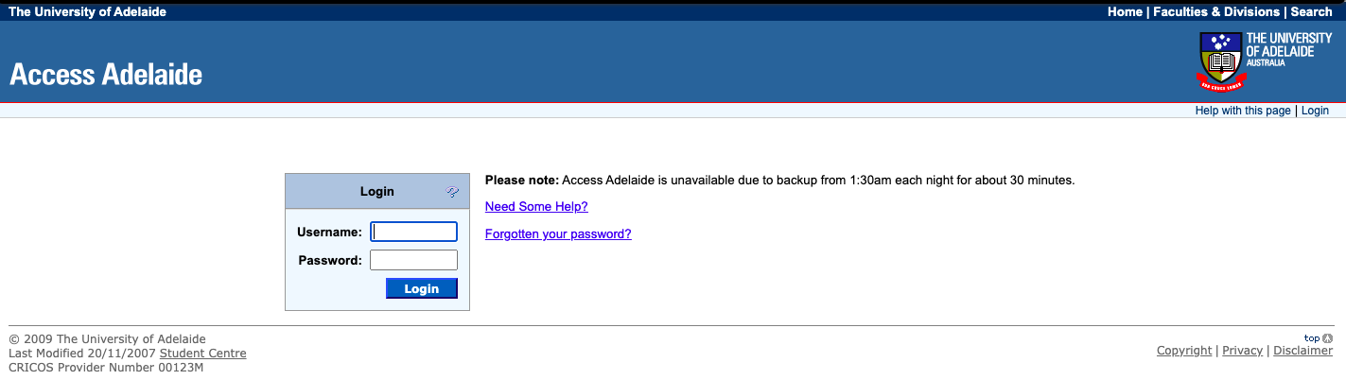
The 2009 version of Access Adelaide basically has no differences to the current version, except the Uni logo changed.

Q08
Step01: Scanning ports from 20000 to 60000. Result shows the port 55554 is opened.
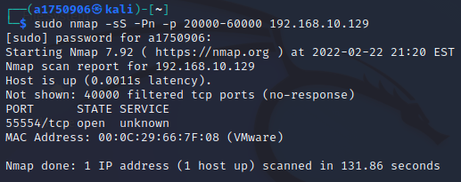
Step02: Using nc -v to connect the port and print everything received.
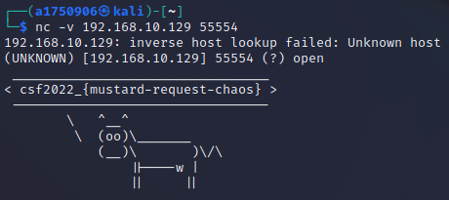

Q09
Step01: A simple script sending SYN to port 1122, 2233, 3344 in order to knock the port 12345. And use netcat the observe the information from 12345.
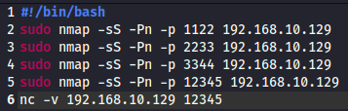
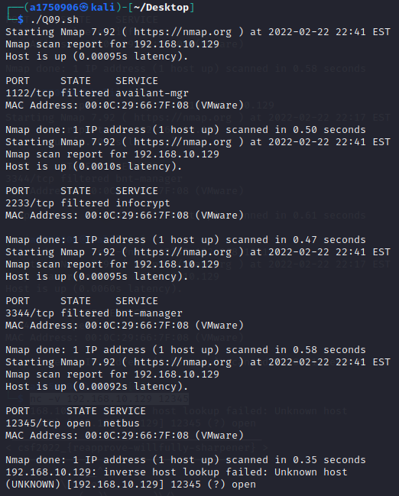
Answer:
